Odd Space

Art Bible

Chaotic Evil

Òscar Canales, Raul Cano, Denis Deconinck, Carles Garriga, Alex Gesti, Pol Pallarés

**Índex**

**Introduction** **3**

**Format** **3**

Sprite size 3

Naming convention 3

Color options 3

**Art Style and Level of Detail** **4**

**Camera Position** **6**

**Color Palettes** **7**

Main Character 7

Space Pirates 8

Head Chef 8

Old Captain 9

Drunk Men 10

Bat 10

Rat 11

Giant Rat Boss 11

Fancy Ship 12

Rusty Ship 12

**Character Design** **13**

Main Character 13

Old Captain 13

Rat Enemies 14

**Environment Design** **15**

Mood Boards 15

Ships 15

Space Bar 15

Dungeon 16

Level Sketches 16

# Introduction

This document defines the Art Style for the game Odd Space and must be followed during the creation of assets and their design.

A set of guidelines and pillars will be shown in this document to define the art for the characters, the environments and the UI.

# Format

## Sprite size

* **Characters, NPCs, Enemies:** 64x64px or 48x48px
* **Weapons, Armor, Objects, Key objects:** 32x32px
* **Buildings, Vehicles, Props, Background:** 48x48px

## Naming convention

“m” stands for “map”, it is used for sprites that will be used in the map.

“c” stands for “combat”, it is used for sprites that will be used during combat scenes.

“w” stands for “world”, it is used for sprites that will be used in the world.

“mn” stands for “menu”, it is used for sprites that will be used in menus like start or pause.

“XX” is the number of the current file version.

* **Characters:** char_name_vXX_w/c
* **NPCs:** npc_name_vXX_w/c
* **Enemies:** nme_name_vXX_w/c
* **Weapons:** wpn_name_vXX
* **Armor:** arm_name_vXX
* **Objects:** obj_name_vXX
* **Key objects:** kobj_name_vXX
* **Buildings:** bld_name_vXX
* **Vehicles:** vhe_name_vXX_m/w
* **Props:** prop_name_vXX_m/c/w
* **Background:** bg_name_vXX_m/c/w/mn
* **User Interface:** ui_name_vXX_m/c/w/mn

## Color options

RGB will be used for all digital content (sprites, textures, particles, logos, promotional art).

CMYK will be used for printable art (posters, promotional art).

# Art Style and Level of Detail

The game will have a 2D Pixel Art Style. To allow the development to advance at a decent speed, the target level of detail of the sprites we produce is going to be medium. Nonetheless, the asset packs we can obtain will allow the game to have a higher level of detail in things such as the environment or the props.

Below are examples of low level of detail and high level of detail, which we are going to try to avoid as much as possible to keep the consistency.

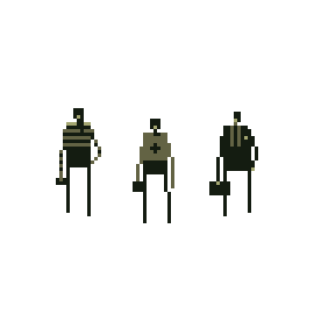

*Superbrothers: Sword and Sorcery (2011)*

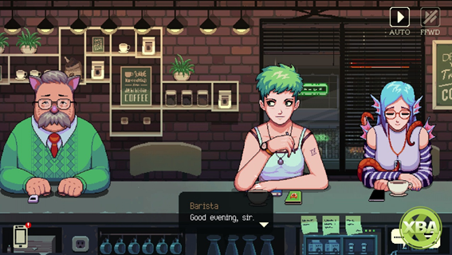

*Coffee Talk (2020)*

Instead, we will use a point in the middle, such as the following examples:

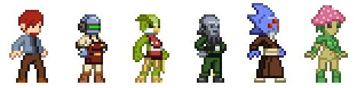

*Starbound (2016)*

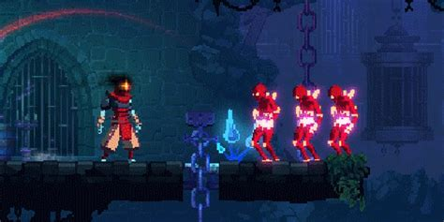

*Dead Cells (2018)*

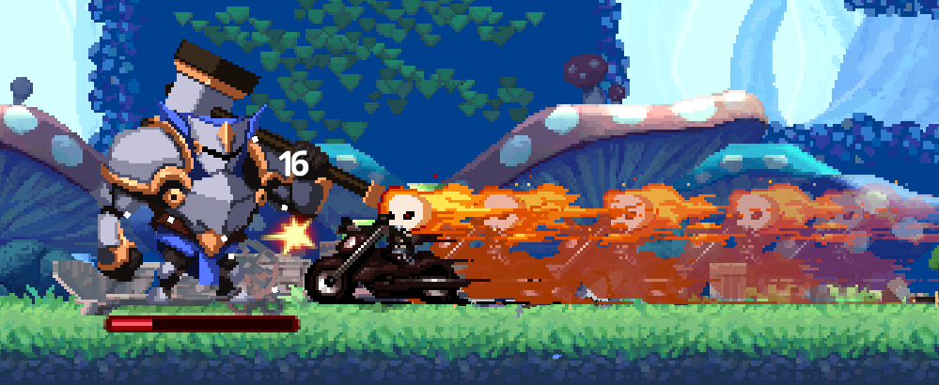

*Skul: The Hero Slayer (2021)*

# Camera Position

The game will use a top-down view such as the ones from the following images.

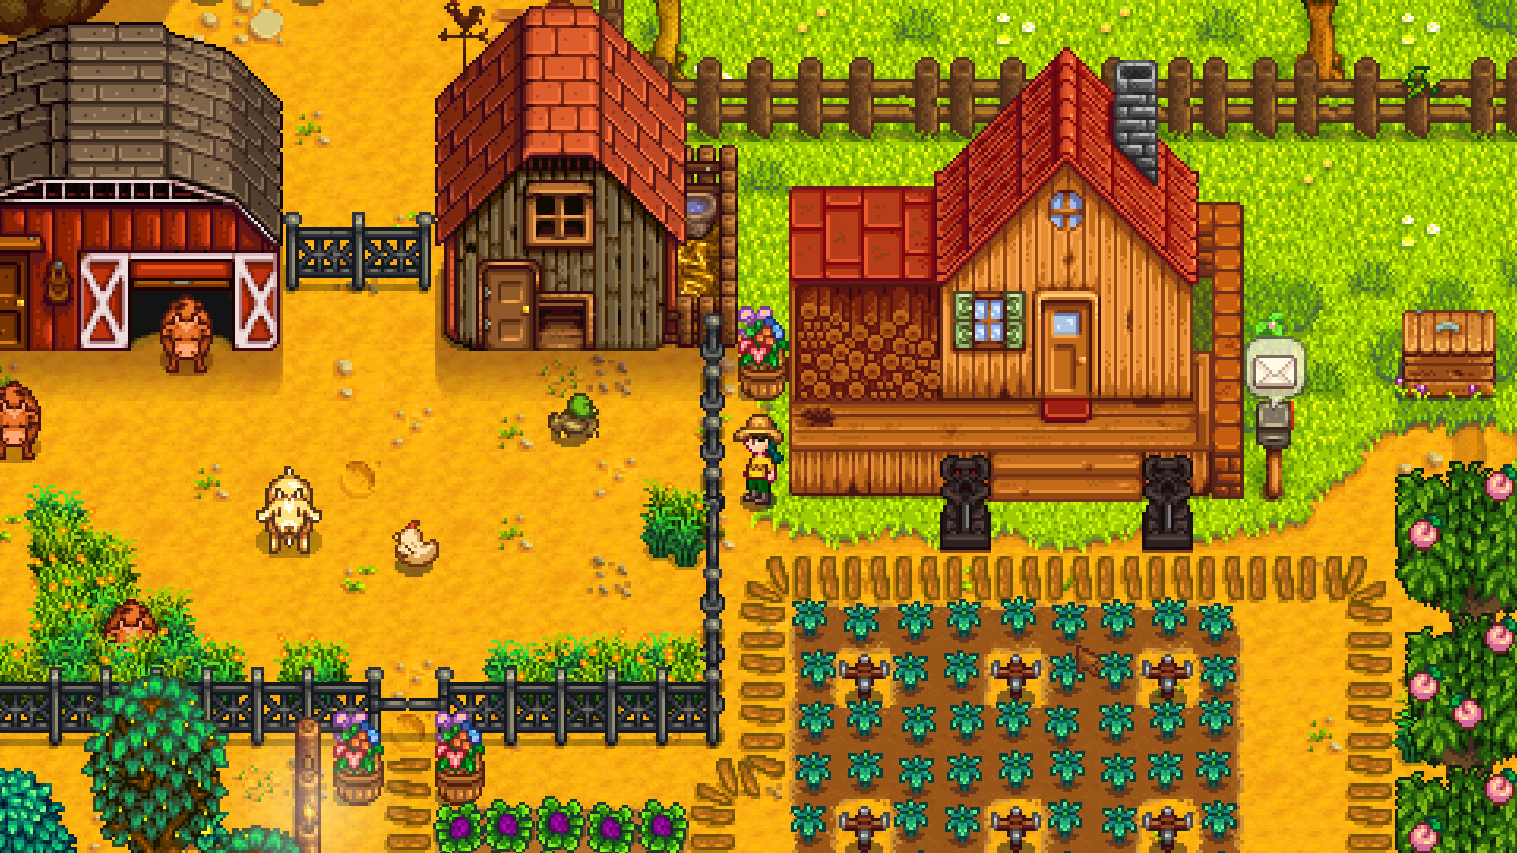

*Stardew Valley (2016)*

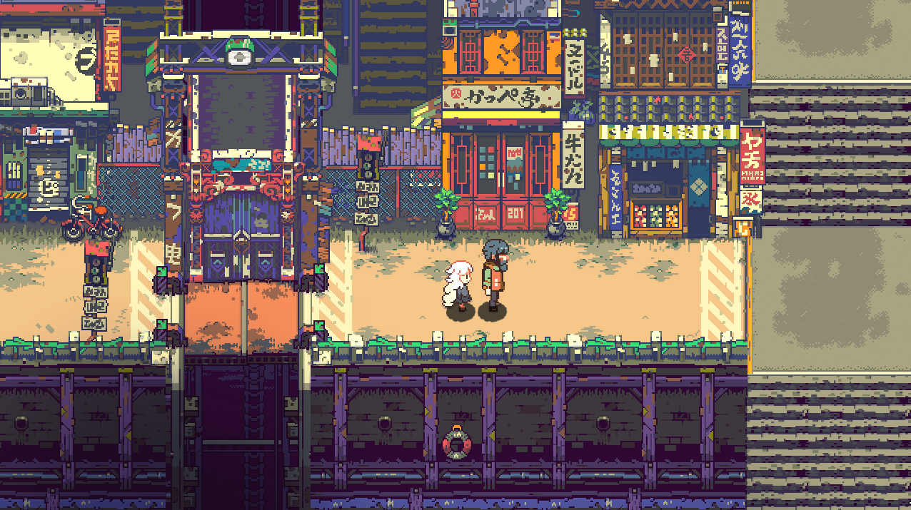

*Eastward (to be released in 2021)*

# Color Palettes

## Main Character

The main character has a basic clothing with drapes and leather, apart from that, it will have two main accents that give detail to the character. There's two different versions of these accents for possible iterations of the character in different game loops.

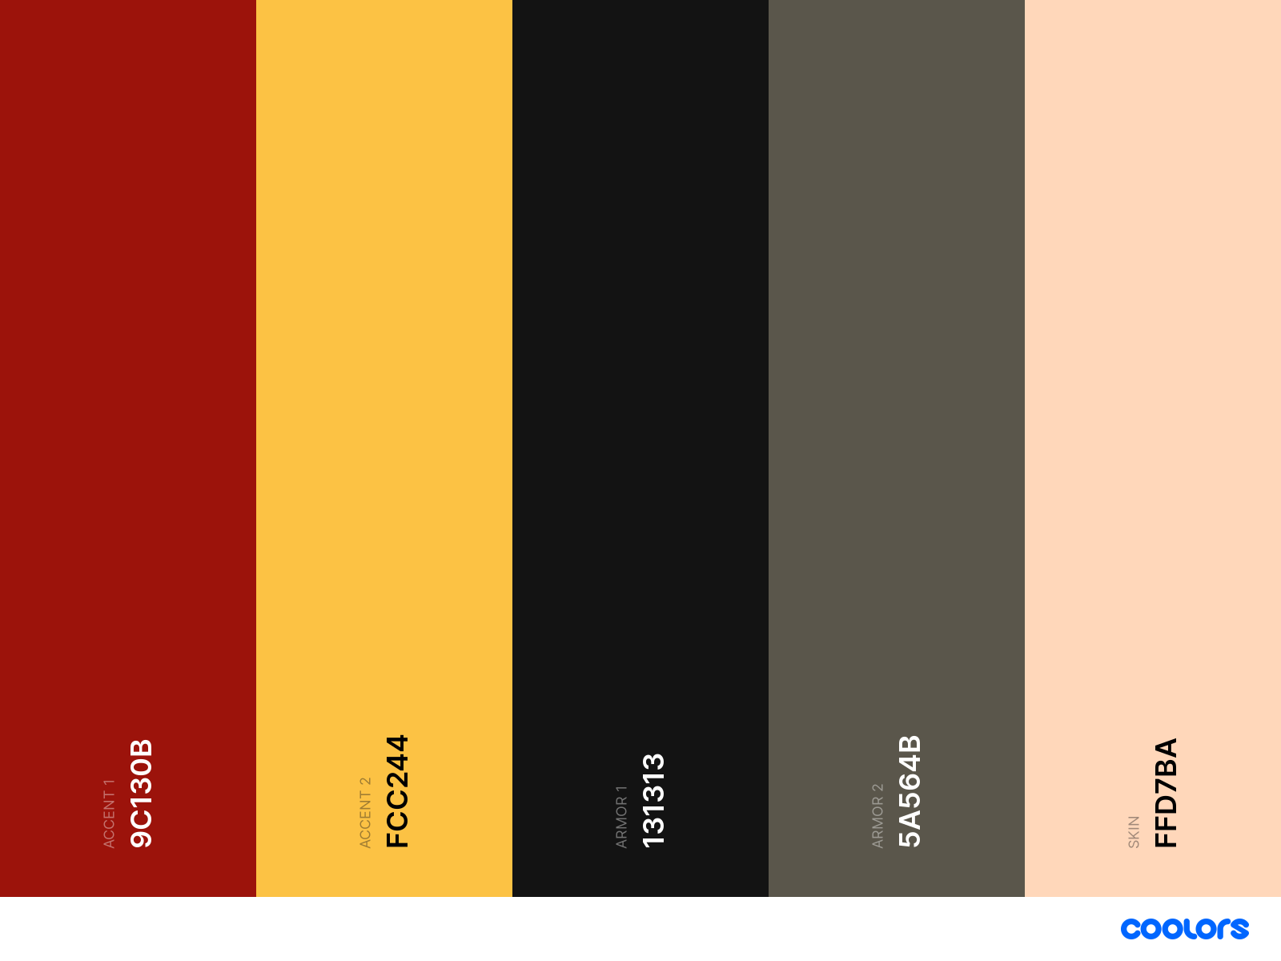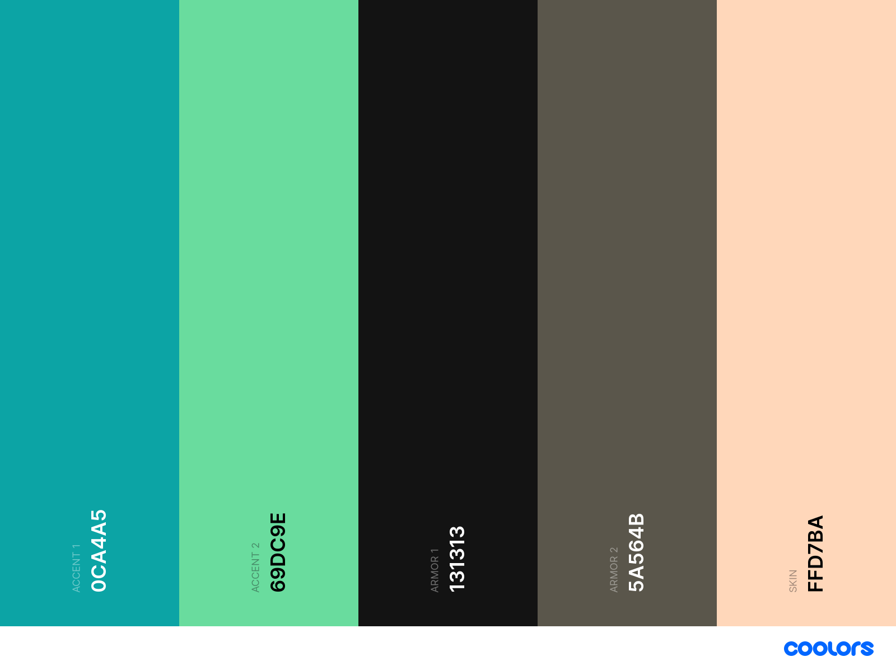

## Space Pirates

The space pirates that appear in the first scene need to have a clean look and have a "sciency" appearance, that's why we use the blue cold colors with a pastel or white-ish tone.

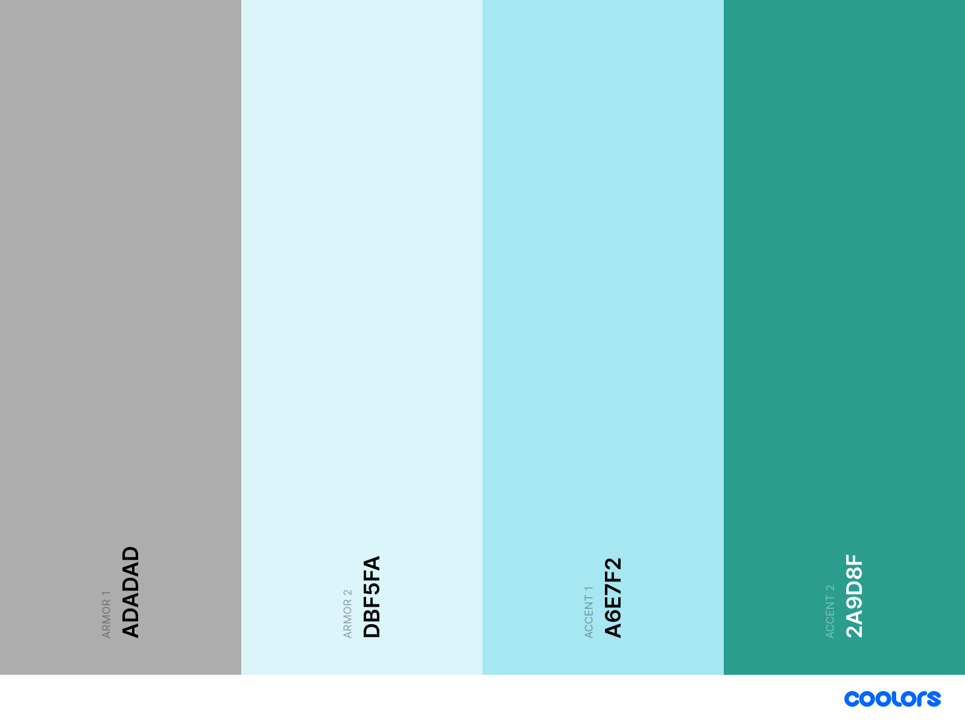

## Head Chef

The Head Chef we encounter in the first Scene has to appear like a working man, but still denote cleanliness, we will do that by using white colors and the vivid color of the hair in combination with the stains colors.

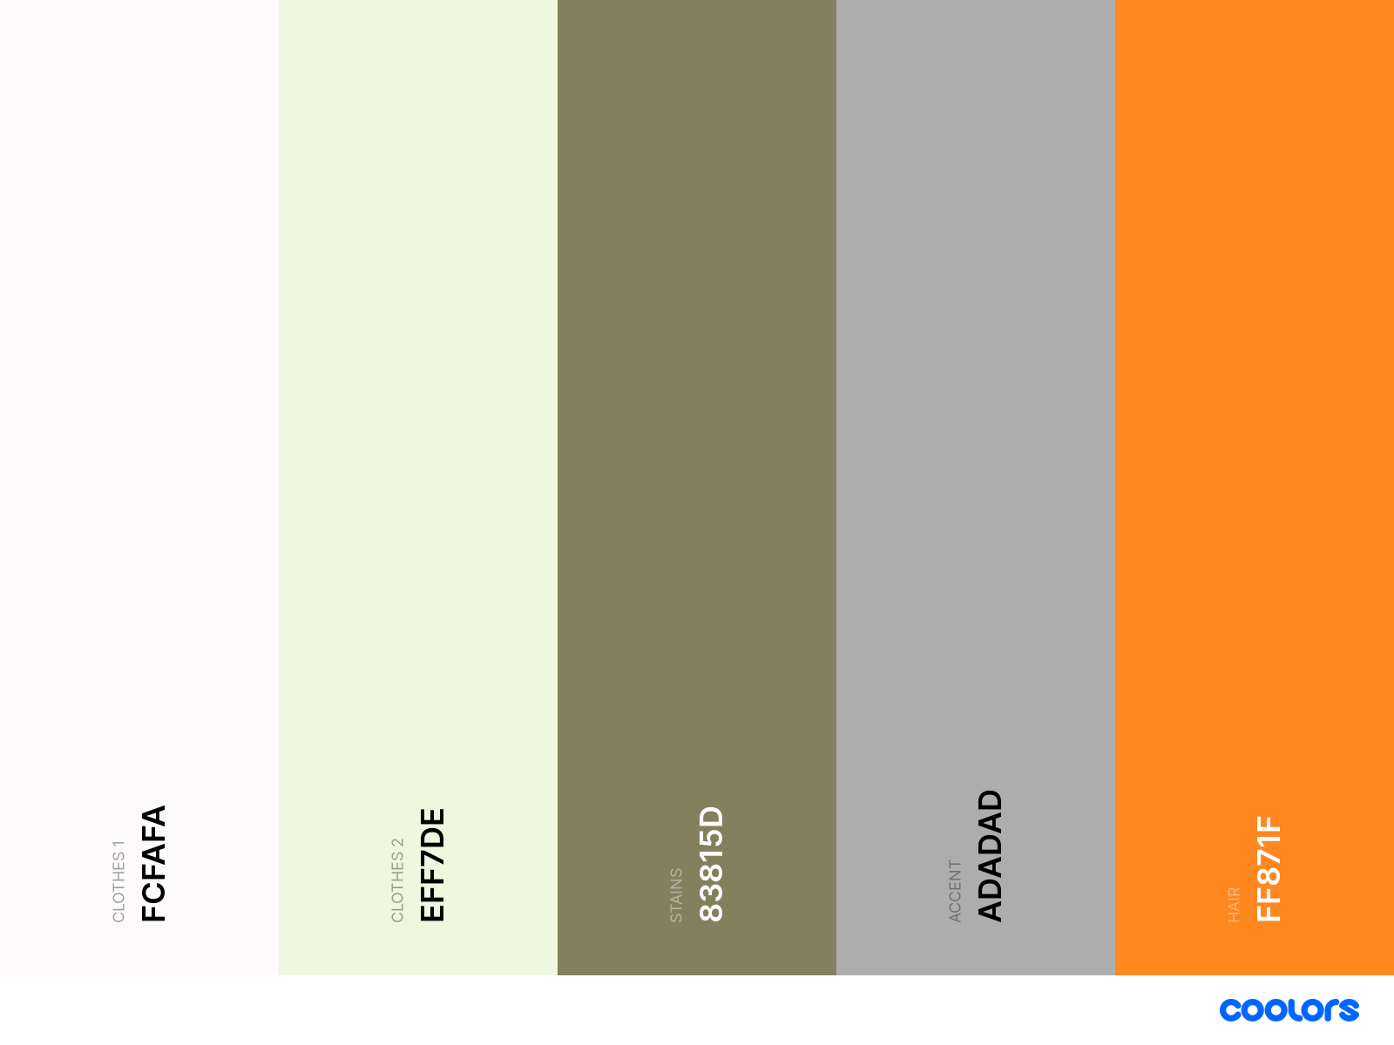

## Old Captain

This character has dark tones in his clothes and has a white (or blonde) beard, he has a pink skin typical of the classical drunk men's skin.

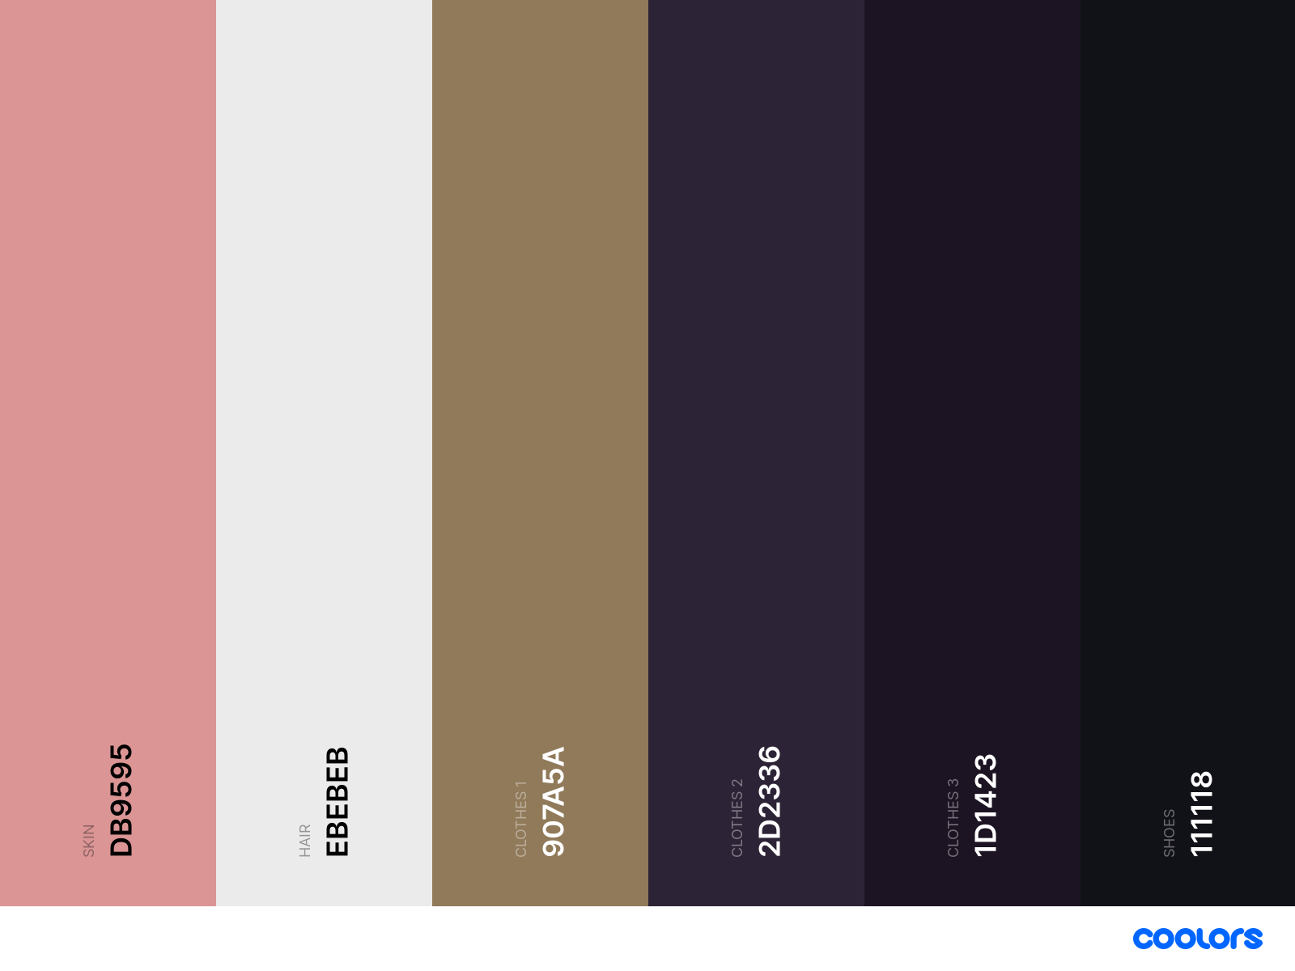

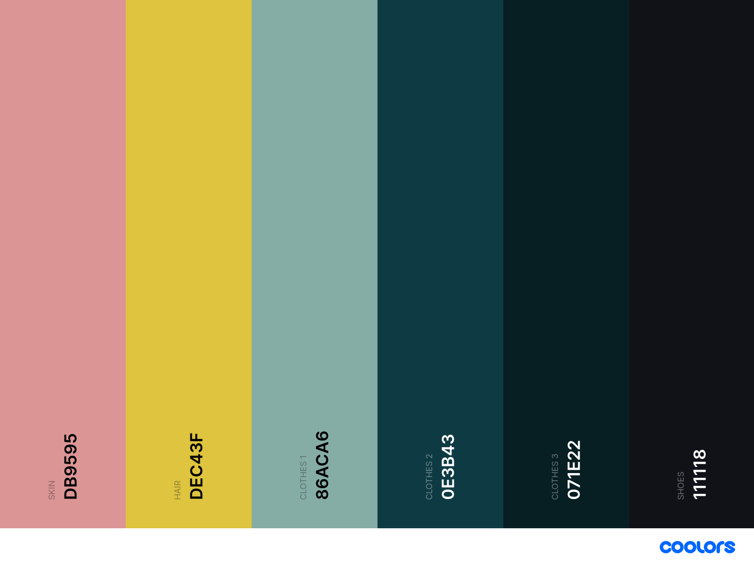

## Drunk Men

The drunk men at the bar will have brown colors that are similar to the ale they drink, they are designed this way to signify they are basic enemies with nothing too special or crazy about them.

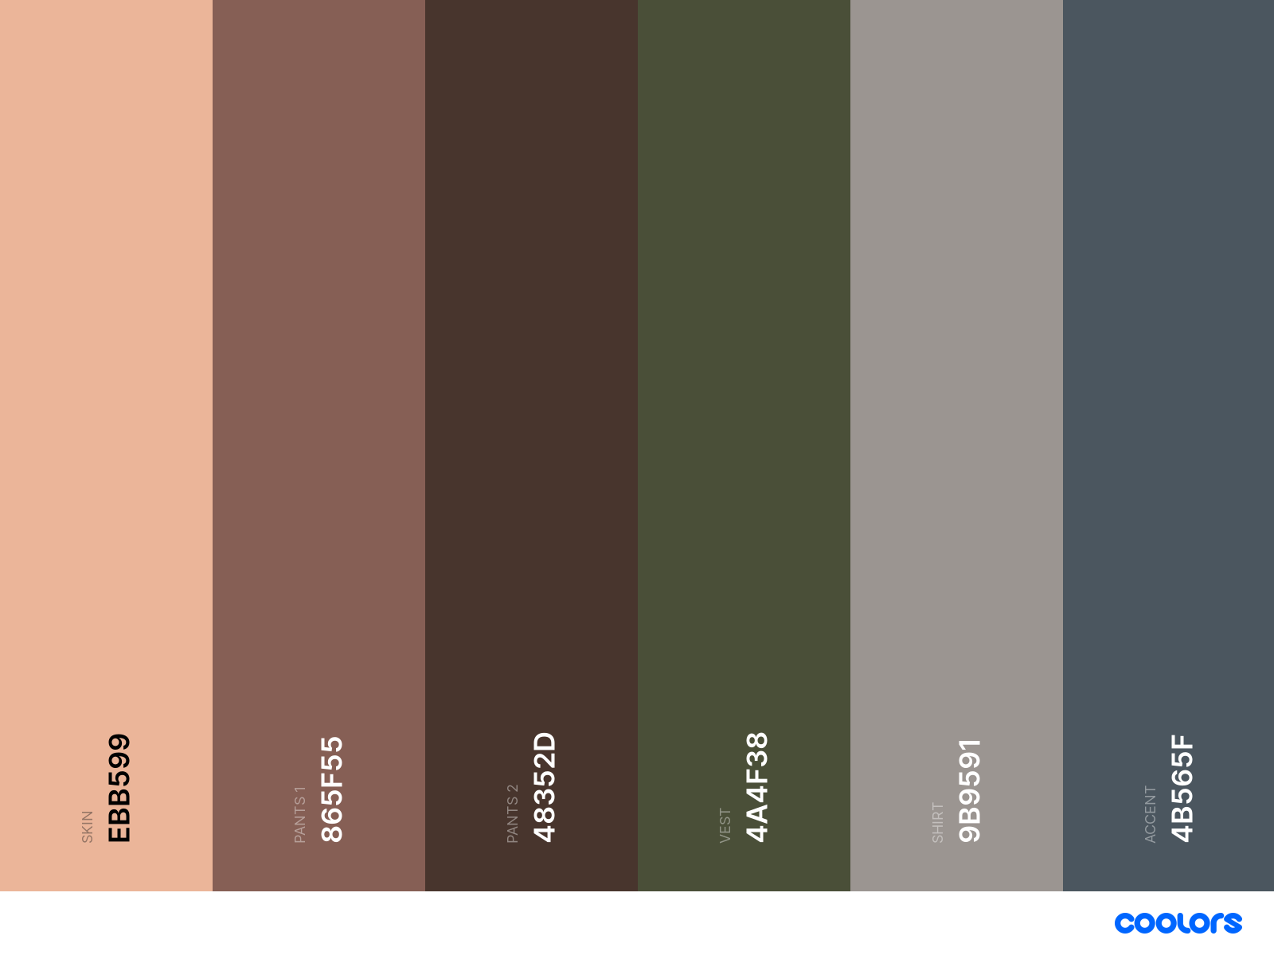

## Bat

The bat will be the first enemy we find in the wild, we will give them bright colors in the red/purple scale that remind us of the blood sucking abilities.

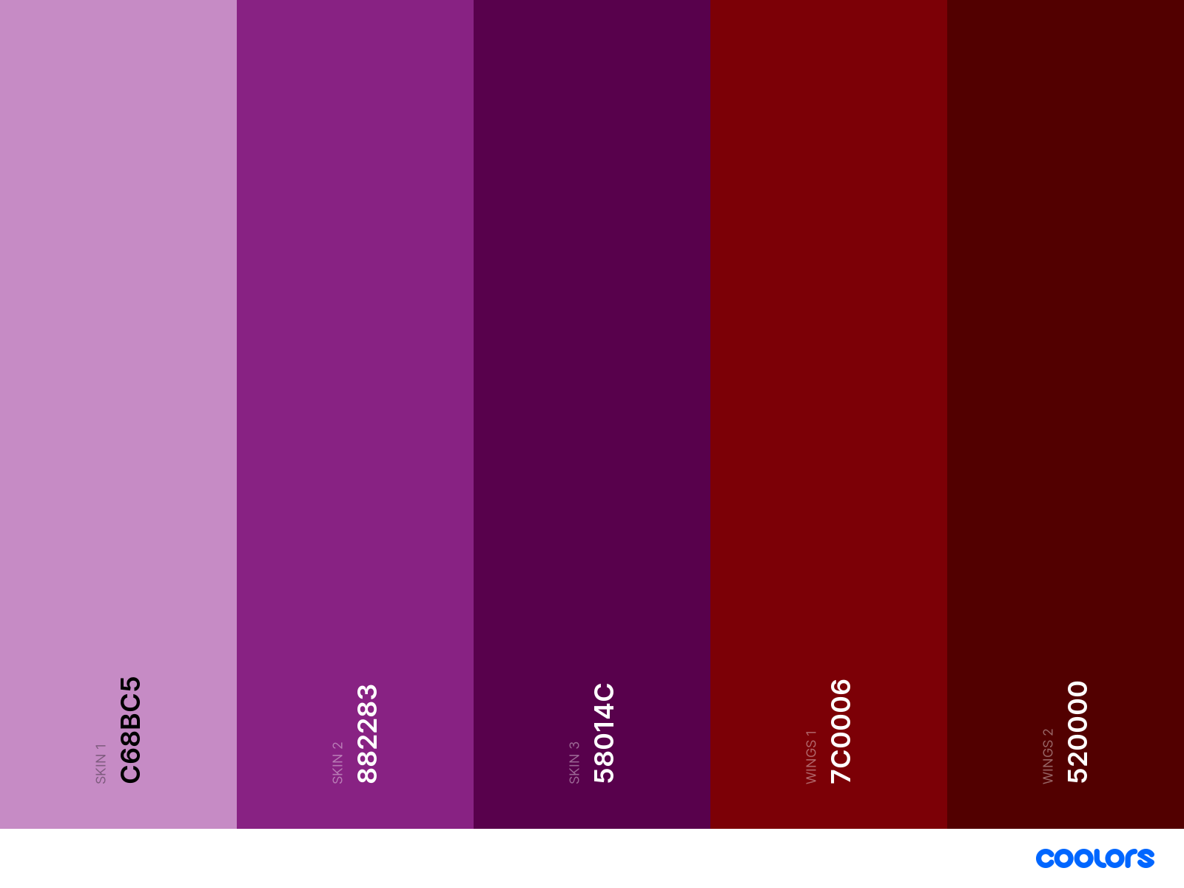

## Rat

The small rats will be a weak enemy in a space where we will also find a boss, that's why we keep the colors simple with minor red touches.

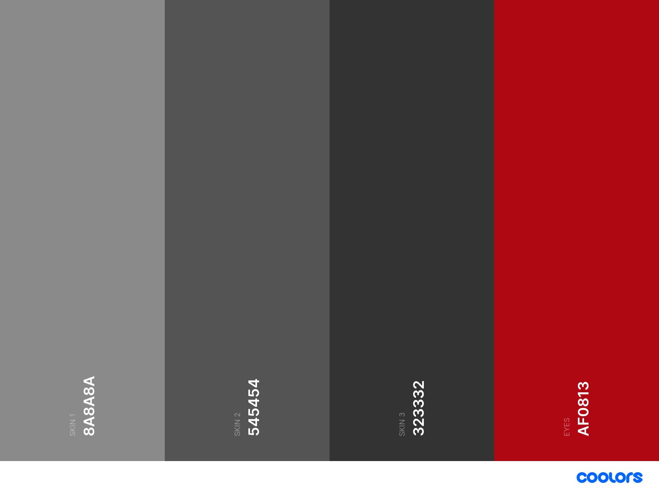

## Giant Rat Boss

This is the strong boss we fight, it follows the same color palette as the normal rat, but adds some clothing and will have more red accents.

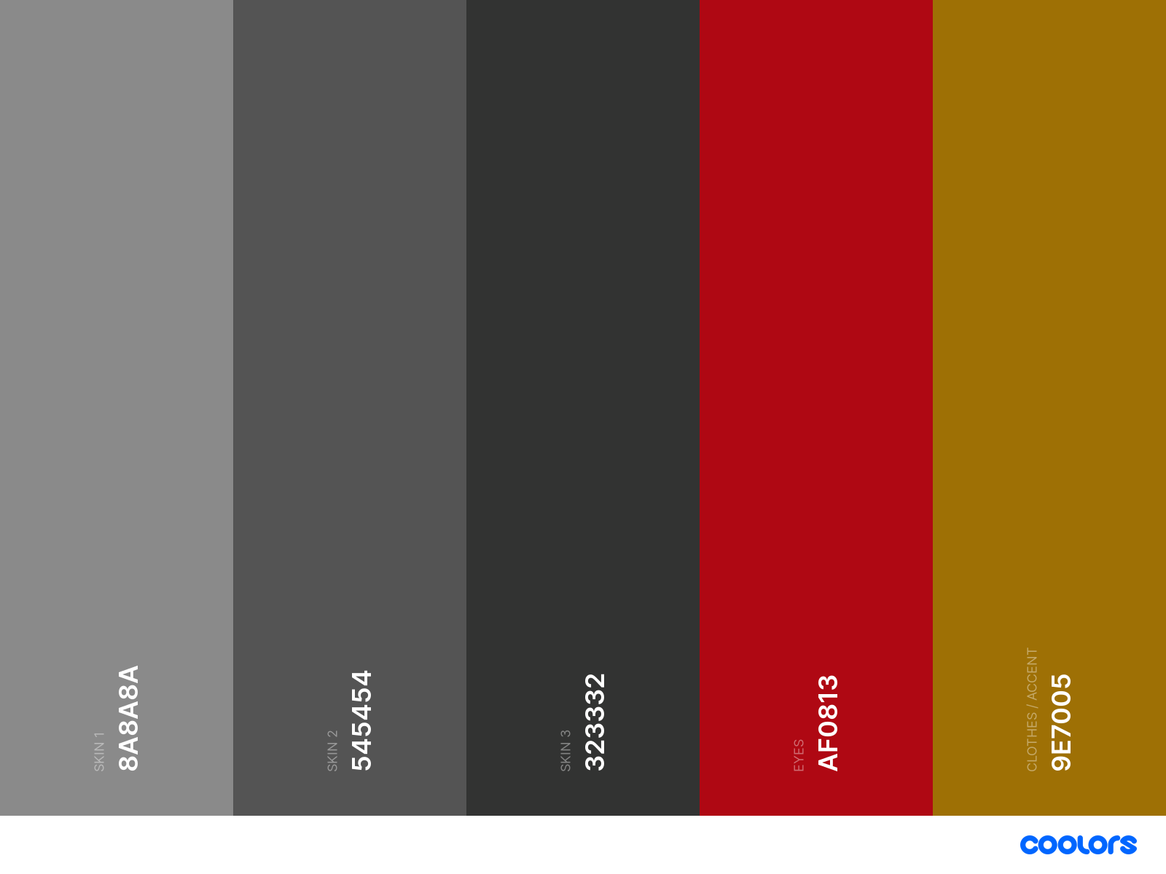

## Fancy Ship

This is the ship we find ourselves in at the beginning of the came, to show the contrast with the latter ship, it will have blue colors as well as the wood and the metal ones.

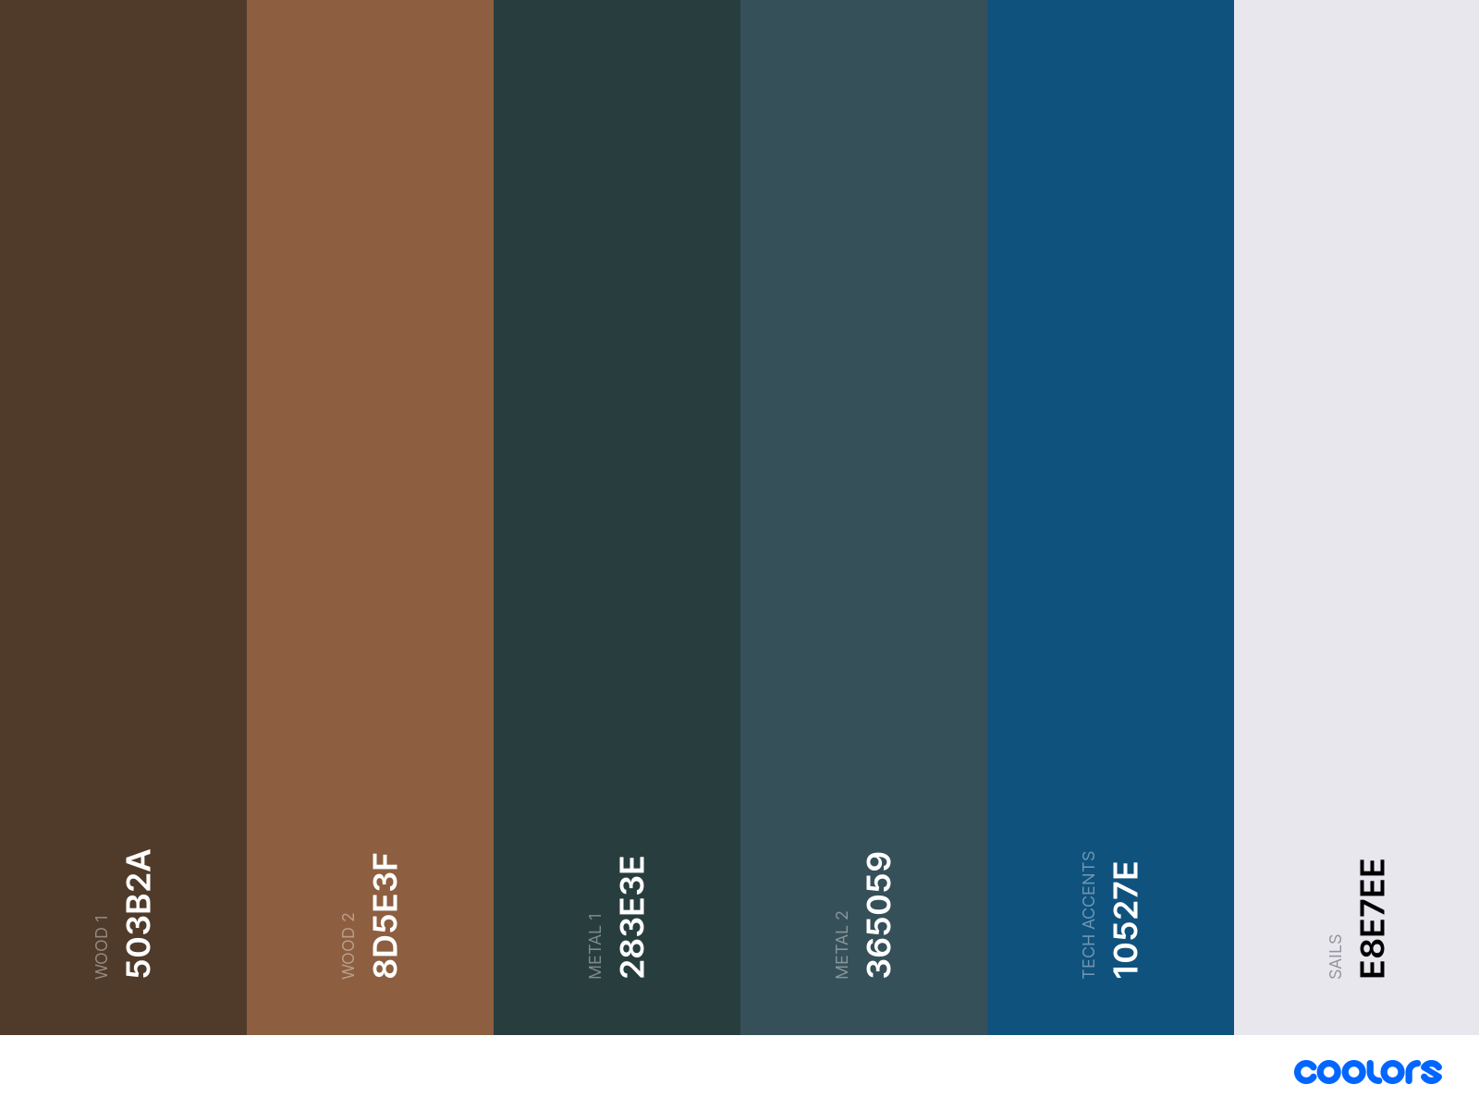

## Rusty Ship

This rusty ship will have used metal and rusty tones, along with dirty green.

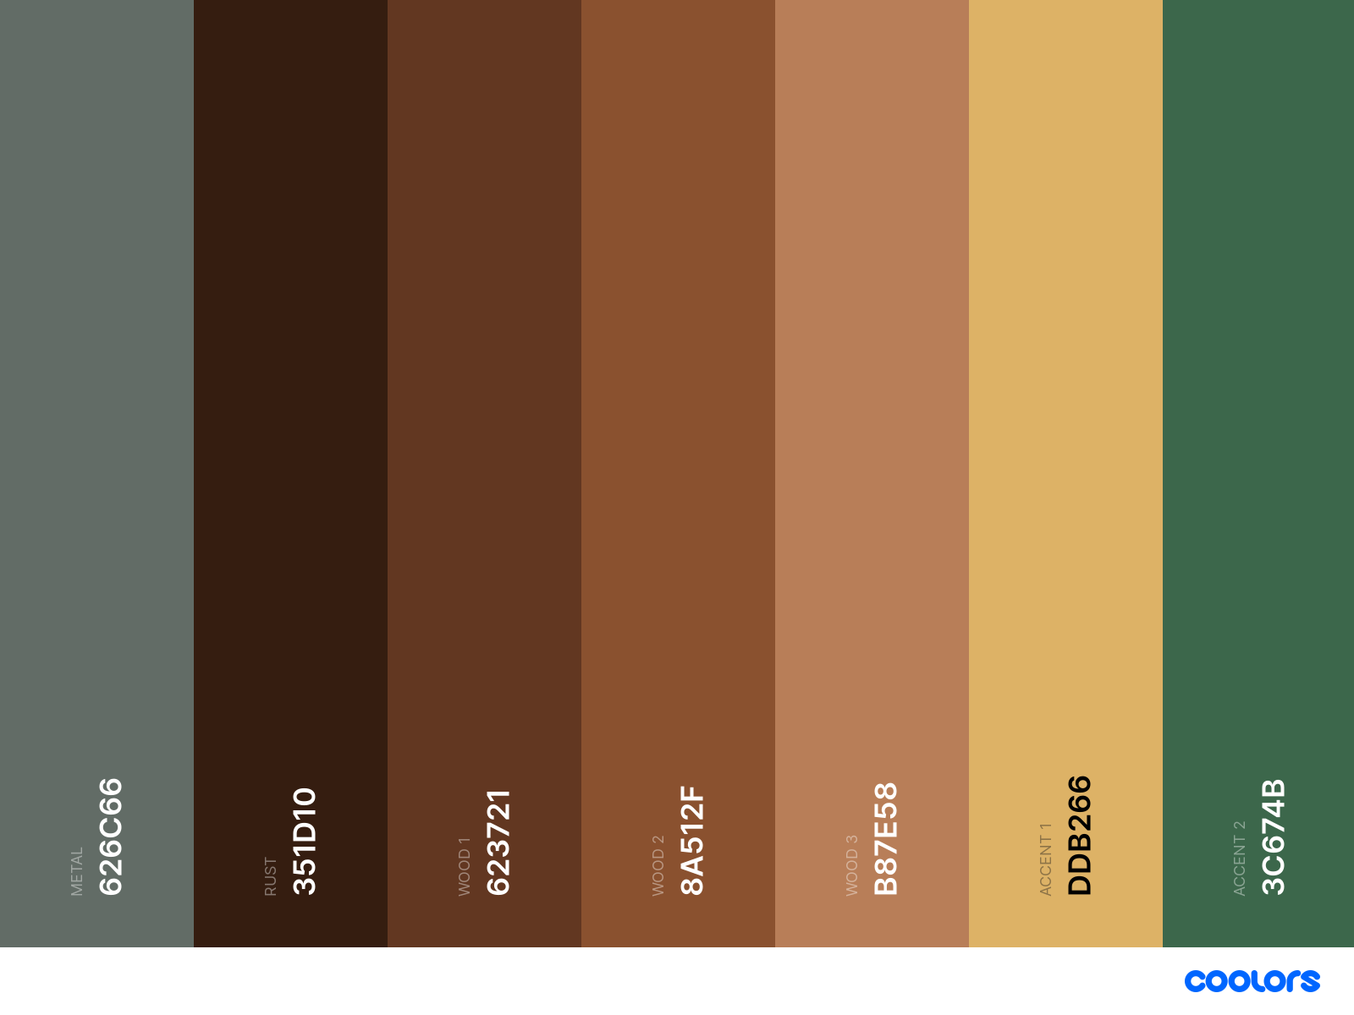

# Character Design

## Main Character

The main character is a young adult that has a carefree personality, he is also witty and tries to make things go his way, although he is always shocked by the minor weird things that happen. He wields an amazing spatula to attack his enemies as he is only a kitchen boy aspiring to be a pirate.

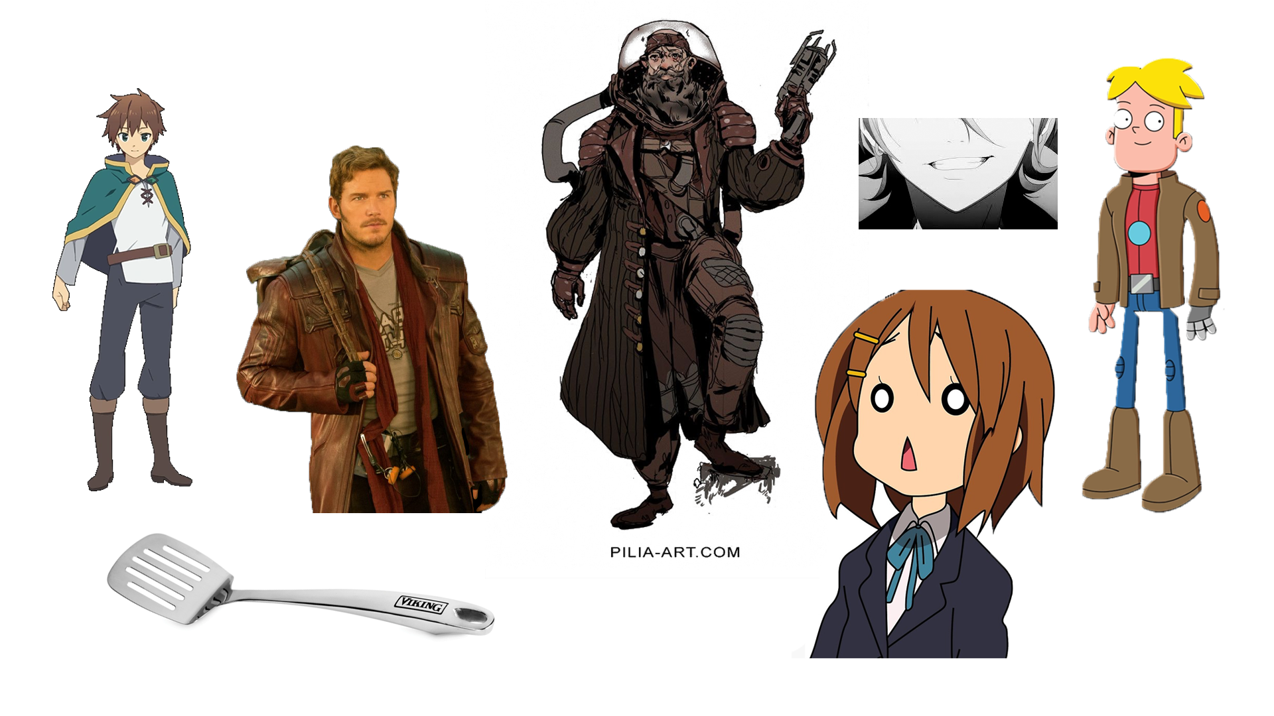

## Old Captain

He is a crazy man with crazy ideas and even crazier drinking. He looks like a grumpy old person who used to be somewhat important in the piracy world.

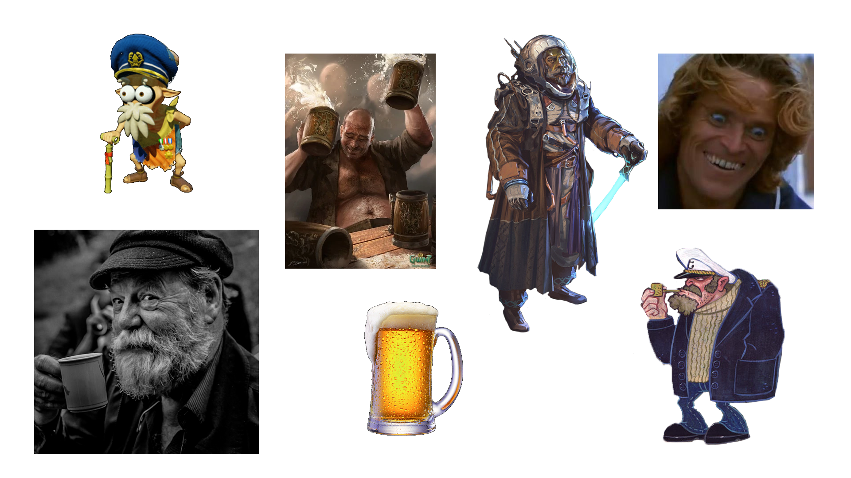

## Rat Enemies

The rats are the classic enemies that will annoy you. They look like they've fought a lot, maybe even between themselves, that's why they're scarred. Their leader will be a much bigger rat with a scar on it's eye.

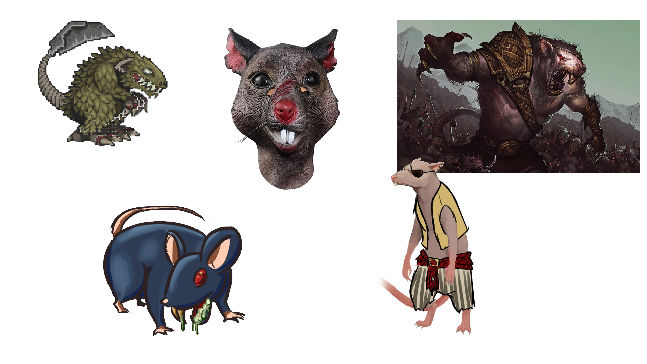

# Environment Design

## Mood Boards

### Ships

The ships will have a bit of a steampunk style and draw inspiration from the Treasure Planet ship. Depending on the quality of the ship, they'll be more or less futuristic and have different levels of cleanliness.

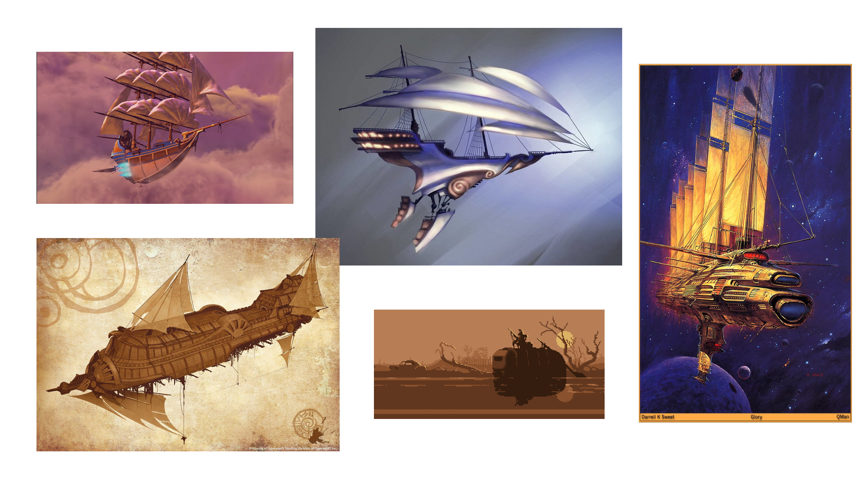

### Space Bar

This will be a small base on an asteroid that will have a bar and a broken gas station on it. The bar tender could have a similar style to the one from the movie Passengers. The people there would be drunken grunts that are always ready for a brawl.

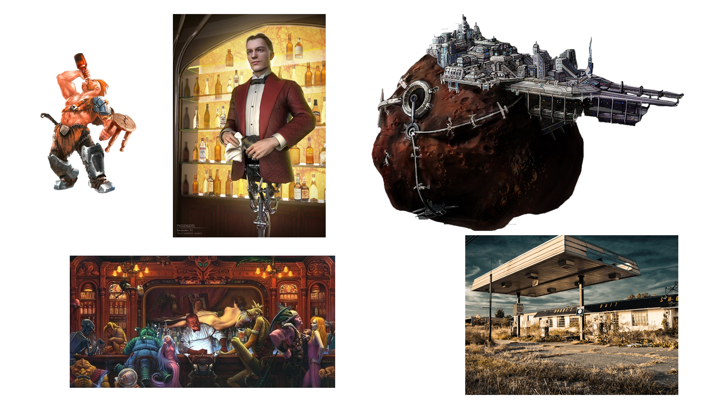

### Dungeon

The dungeon will be set on a remote, dark and cold planet. It will have old ruins with skeletons and broken structures.

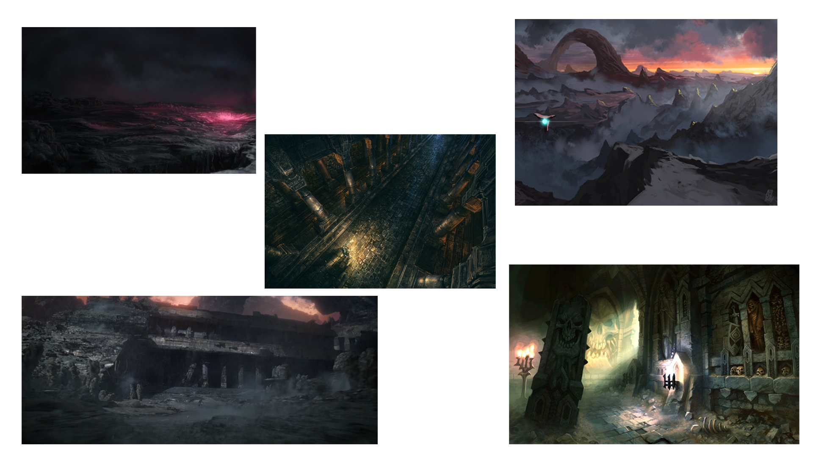

## Level Sketches

